CURRICULUM VITAE
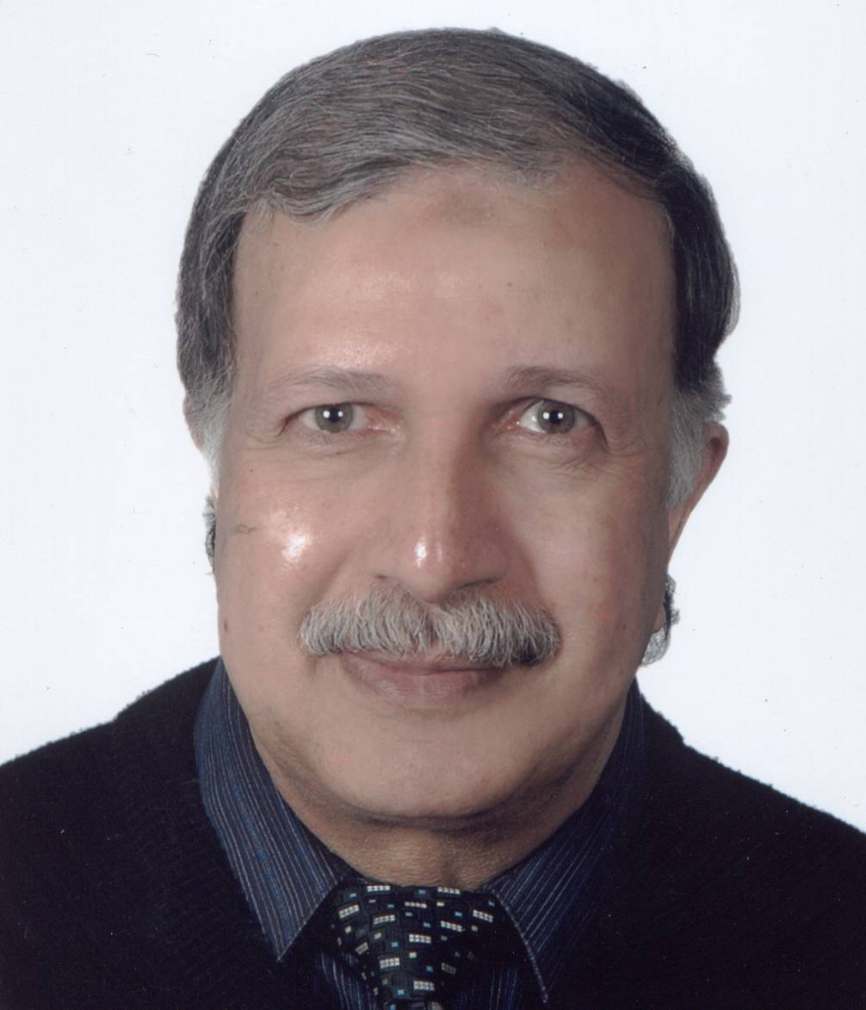

NAME: MAHMOUD A. ABDELNABI

TITLE: PROFESSOR of AVIAN PHYSIOLOGY, DEPARTMENT OF POULTRY SCIENCE FACULTY OF AGRICULTURE, ASSIUT UNIVERSITY.

EDUCATION:

Ph. D. 1990: MARYLAND UNIVERSITY, COLLEGE PARK, MD, USA (AVIAN PHYSIOLOGY, NEUROENDOCRINOLOGY) THESIS TITL: NEUROCHEMICAL AND HORMONAL CORRELATE OF SEXUAL BEHAVIOUR IN THE BRAIN OF THE JAPANESE QUAILS

M. Sc.1979: ASSIUT UNIVERSITY, ASSIUT, EGYPT (REPRODUCTIVE PHYSIOLOGY, ARTIFICIAL INSEMINATION) THISIS TITLE: STUDIES ON SOME PRODUCTIVE AND REPRODUCTIVE TRAITS IN RABBIT UNDER UPPER EGYPT CONDITION.

B.Sc. 1973: ASSIUT UNIVERSITY, ASSIUT, EGYPT(POULTRY SCIENCE, POULTRY PRODUCTION)

POSITION HELD:
1- June 1, 2004- September 30, 2004 Visiting professor, Animal and avian science department, Maryland University, College park, USA.
2-March 2002-May 30, 2004. Visiting professor, Psychiatry Department, Illinois University, Chicago, USA.
3-1998- March 30, 2002.Faculty Research Assistant, Animal and avian science department, Maryland University, College park, USA.
4- 1990-1998. Assistance professor, Animal and Poultry production Department, Assiut University, Assiut, Egypt.
5- 1984-1990. Graduate fellow, Poultry Science Department, Maryland University,College park, USA.
6-1973-1984. Teaching and Research Assistant, Animal and poultry Production Department, Assiut University, Assiut, Egypt.

MAIN TEACHING ACTIVITIES:
1-Avian physiology.
2- Endocrinology.
3-Reproductive physiology.
4-Poultry Production.

TRAINING PROGRAMS:
- Molecular Radiation Protection Training Course: Presented by the radiation safety office, department of environmental safety, University of Maryland, College park, USA.
2-Biology workshop: Technique in molecular biology. Provided by the University of Alexandria Research Center, Egypt.
3-Animal Care and Use Training Program. Provide by the Institute of Animal Care and Use, University of Maryland, College park, USA.

MEMBERSHIP:
1-Egyptian Poultry Science Association.
2-Rabbit Science Association.
3- World Poultry Science Association.

CONTRACTS, GRANTS AND HONORS:
1-1992-1995 National Agriculture Research Project (NARP) award for project “Physiological and biotechnological studies towards reproductive potential improvement of Dandarawi chicken” $447.000. Project in collaboration with Dr. Mary Ann Ottinger, Maryland University, College Park, USA.

2-1998. Invited as interpreter in workshop on “Monitoring and evaluation of agricultural development programs”. The workshop was held in the University of Maryland at College Park as a part of collaborative project between the Ministry of agriculture in Egypt and the University of Maryland.

3-2000. Invited as guest speaker to present a lecture in the World’s Poultry Congress. Montreal, Canada, August 20-25. The lecture titled “Lifetime reproduction and environmental factors”.

PUBLICATIONS

Ottinger MA, Lavoie ET, Abdelnabi M, Quinn MJ Jr, Marcell A, Dean K, (2009). An overview of dioxin-like compounds, PCB, and pesticide exposures associated with sexual differentiation of neuroendocrine systems, fluctuating asymmetry, and behavioral effects in birds. J Environ Sci Health C Environ Carcinog Ecotoxicol Rev.;27(4):286-300.
Mary Ann Ottinger, Emma Lavoie, Nichola Thompson, Ashley Barton, Kasen Whitehouse, Meredith Barton, Mahmoud Abdelnabi, Michael Quinn Jr., GianCarlo Panzicad,, Carla Viglietti-Panzicad (2008).Neuroendocrine and behavioral effects of embryonic exposure to endocrine disrupting chemicals in birds.. Brain Research Reviews, 7,376 – 385.
Abdelnabi, M. A., H. Y. El-Hammady, S.Y. Hussein., and K. F. Abou El-Ezz, (2007) Effect of Age and Housing Condition on Semen Quality of the Local Ganders in Assiut . Egyptian Poultry Science, 27 (II) 487-497 .
Abdel-Raouf M., and Abdelnabi, M. A. (2007).Reproductive performance of male Bouscat rabbits as affected by long-term testosterone propionate or human chorionic gonadotropin administration. J. Agric. Sci. Mansoura Univ., 32 (7):5055-5064
Abdelnabi, M. A. (2007).Feed Consumption in Relation to Egg Formation and Environmental Temperature in Dandarawi and Hy-Line Strains. J. Agric. Sci. Mansoura Univ., 32 (7):5065-5070.
El-Hammady, H. Y., Abdelnabi M. A., Youssef H. S.and Abou El-Ezz. F.K. (2007). Growth performance of theEgyptian geese under sub tropical conditions in Assiut. The Egyptian Poult. Sci. Association. 4th World’s Poultry Conference, Sharm El-Sheikh, Egypt, March 27-30-.
El-Hammady, H. Y., S. Youssef, Anas A. Salem , M. Abdelnabi. and A. Ali (2005). Effect of hCG injection on some reproductive performance in California and Bouscat rabbits. Egyptian Soc. Anim. Reprod. Fert. 17th annual Cong., Al-Minia, 29-2 February
Ottinger, M. A., Mobarak M. ., M. A. Abdelnabi, G. Roth, J. Proudman, and D.K. Ingram (2005). Effect of calorie restriction on reproductive and adrenal systems in Japanese quail: Are responses similar to mammals particularly primates? Mechanisms of Aging and Development. 126: 967-975.
Ottinger, M. A., M. J. Quinn Jr., E. Lavoie, M. A. Abdelnabi, N. Thompson, J.L. Hazelton, J. M. Wu. J. Beavers and M. Jaber,(2005). Consequences of endocrine disrupting chemicals on reproductive endocrine function in birds: Establishing reliable end points of exposure. Domestic Animal Endo 29:411-419.
Hahn, D.C., JS Hatfield, M. Abdelnabi, J. Wu, L.D. Igl, M. A. Ottinger, (2005). Inter-species variation in yolk steroid levels and a cowbird-host comparison . J. Avian Biology 36: 1: 40-46
Cohen AH, M.A Abdelnabi, B. Bent, C. Coleman, L. Guan, A. Mitra, M. A. Ottinger, and L. Chakrabarti, (2005). Changes in distribution of serotonin induced by spinal injury in larval lampreys: evidence from immunohistochemistry and HPLC.J Neurotrauma, 22 (1):172-188.
Ottinger, M. A., J. Wu, J. Hazelton, N. Thompson, M. Quinn, M. Abdelnabi, M. Ruscio, J. Beavers and Mark Jaber, (2005). Assessing the consequences of the pesticide Methoxychlore:Neuroendocrine and Behavioral Measures as Indicators of biological impact of an environmental agent with estrogen activity. Brain Research Bulletin (Special Issue) 65, 199-209.
Ottinger, M. A., M. A. Abdelnabi, Q. Li, K. Chen, N. Thompson, N. Harda, C. Viglieui-Penzica and G. C. Penzica, (2004).The Japanese quail: a model for studying reproductive aging of hypothalamus systems. Experimental Gerontology 39:1679-1693.
Bales KL, Abdelnabi M A, Cushing BS, Ottinger MA and Carter CS, (2004). Effects of neonatal oxytocin manipulations on male reproductive potential in prairie voles. Physiol. Behav. May;81(3):519-26.
Lin F, Wu J, Abdelnabi M A, Ottinger MA, and Giusti MM, (2004). Effects of dose and glycosylation on the transfer of genistein into the eggs of the Japanese quail (Coturnix japonica). J Agric Food Chem. 52, 2397-403.
Bakir, A. A., El-Gammal, N. M. Esa and M. A. Abdelnabi,(2004). Liver enzymes activity as affected by force molting in some local strains of Egyptian chickens. XXII World’s Poultry Congress. Estanbul, Turkey.
Abdelnabi MA, and M A Ottinger, (2003). Hypothalamic indolamines during embryonic development and effects of steroid exposure. Gen Comp Endocrinol. Jan; 130(1):13-9
El-Gammal, A.M., A. A. Bakir, N. M. Esa and M. A. Abdelnabi,(2003). Force molting in Fayoumi and Dandarawi cocks and its effect on semen characteristics. Egypt. J. Agric. Res., 81(1), 285-295.
Ottinger MA, Abdelnabi MA, Quinn M, Golden N, Wu J, and N Thompson (2002). Reproductive consequences of EDCs in birds. What do laboratory effects mean in field species?Neurotoxicol Teratology. 24(1):17-28.
Ottinger,M. A., S. Pitts and M. A. Abdelnabi (2001). Steroid hormones during embryonic development in Japanese quail: plasma, gonadal and adrenal levels. Poultry Sci., 80:795-799.
Abdelnabi, M. A., M. P. Richards, and M. A. Ottinger (2001). Comparison of gonadal Hormone levels in turkey embryos incubated in long term shell less culture and in ovo. Poultry Sci.,80-666-669.
Ottinger,M. A, M. A. Abdelnabi, P. Henery, S. McGary, N. Thompson and J. Wu (2001). Neuroendocrine and behavioral implications of endocrine disrupting chemicals in quail. Hormone and Behavior. In press in Sept. Issue.
Abdelnabi, M. A., M. R. Bakst, J. E. Woods and M. A. Ottinger (2000). Plasma 17B Estradiol levels and ovarian interstitial cell structure in embryonic Japanese quail.Poultry Sci., 79 : 564-567.
Abdelnabi, M. A. and M. A. Ottinger (2000). Life time reproduction and environmental Factors. XXI World’s Poultry Congress, Montreal Canada.
Daghash, H. A. G. A. Megahed and M. A. Abdelnabi (1999). The influence of feeding Nigella sativa seeds on semen quality and fertility improvements of bucks with special references to thermal physiological response and some plasma constituents. Egyptian Soc. Anim. Reprod. Fert. Eleventh Annual Congr. Pg. 203-215.
Ottinger, M. A., and M. A. Abdelnabi, (1997). Neuroendocrine system and avian system Differentiation. Am. Zool. 37:514-523.
Daghash, H. A, and M.A. Abdelnabi (1995). Changes in some blood parameters in relation to reproductive status in rabbits. Egyptian Journal of Rabbit Science, 5 (2), 135-146(1995).
Haddad, G.I, M. A. Abdelnabi, and A. A. Farrag (1992). Changes in testosterone, cortisol level and seminal characteristics in relation to collection regimen in rabbits. Assiut Vet. Med. J. 28. NO. 55.
Watson, J. T., M. A. Abdelnabi, S. Wersinger, M. A. Ottinger and E. A. Regan (1990). Circulating estradiol and activation of male and female copulatory behavior in Japanese quail (coturnix Japonica). Gen. Comp. Endocrinol., 77 : 229-238.
Adkins-Regan, E., M. A. Abdelnabi, M. Mobarak and M. A. Ottinger (1990). Sex steroid levels in developing and adult male and female zebra finches (poephila guttata). Gen.Com. Endocrinol., 78 : 93-109.
Ruff, M.D., M.A. Abdelnabi, R.N. Clarke, M. Mobarak and M.A. Ottinger (1988). Effects of coccidiosis on reproductive maturation of male Japanese quail. Avian Disease 32 :41-45.
Makled, M.N., A.M. El-Gammal and M.A. Abdelnabi (1981). Growth and feed utilization of Bouscat rabbits under upper Egypt conditions. A- Growth and feed efficiency-Assiut J. Agri. Sci., 12(4) : 181-189.

Makled, M.N., A. M. El-Gammal and M. A. Abdelnabi (1981). Growth and feed utilization of Bouscat rabbits under upper Egypt conditions. B- Developmental changes of parts and cut-up parts. Assiut J. Agri. Sci., 12 (4): 191-202.

PUBLISHED ABSRACTS
(PH295) Androgen active contaminants disrupt development of the bursa of Fabricius: a possible mechanism of immuno suppression in birds? Quinn, Jr., M, Lavoie, E, Abdelnabi, M, Ottinger, M, A. Fourth SETAC World Congress ,25th Annual Meeting in North America, 14-18 November 2004, Portland, Oregon, USA
(PH284) Aromatase enzyme as an endpoint for embryonic exposure to ethyoxychlor in Japanese quail (Coturnix japonica). McKernan, M, Abdelnabi, M, Hazelton, J, Quinn, M, Thompson, N, Ottinger, M, . Fourth SETAC World Congress ,25th Annual Meeting in North America, 14-18 November 2004, Portland, Oregon, USA
(IP024) Findings from Two-Generation Tests in Japanese and Northern Bobwhite Quail.Ottinger, M¹, Hazelton, J, Quinn, Jr, M, Thompson, N, Mann, L, Barton, A, Abdelnabi, M, Lavoie, E, Beavers, J, Jaber, M, .Fourth SETAC World Congress ,25th Annual Meeting in North America, 14-18 November 2004, Portland, Oregon, USA
(PM204) Assessment of An Embryo Dose Range Finding Protocol In Japanese Quail: Sensitivity To Estradiol. Lavoie, E, Quinn, Jr., M, McKernan, M, Abdelnabi, M, Touart, L, Ottinger, M, . Fourth SETAC World Congress ,25th Annual Meeting in North America, 14-18 November 2004, Portland, Oregon, USA
Comparing Species Sensitivity to Dietary Methoxychlor in a Two Generation Test.
Ottinger, M, Hazelton, J, Quinn, M, Thompson, N , Wu, J, Quigley, E, Abdelnabi, M, Beavers, J, Fry ,L, Jaber, M. SETAC NA 24thAnnual Meeting in North America 9-13 November 2003, Austin, Texas
Estrogenic Endocrine Disrupting Chemicals Impair Reproductive Neuroendocrine and Behavioral Responses in Japanese Quail. Ottinger, M, Hazelton, J, Wu, J, Ruscio, M, Thompson, N, Quinn, M, Abdelnabi, M, Beavers, J, Jaber, M, .SETAC NA 24thAnnual Meeting in North America 9-13 November2003, Austin, Texas
Avian Models for Evaluating the Effects of Calorie Restriction. M.A. Ottinger and M.A. Abdelnabi.(2003). http://www.americanaging.org/2003/abs/Ottinger.htm
The Japanese Quail as an Avian Model for Testing Endocrine Disrupting Chemicals: Endocrine and Behavioral End Points. Ottinger, Mary Ann, Abdelnabi, Mahmoud A., Thompson, Nichola, Wu, Julie, Henry, Kemeka, Humphries, Elizabeth, Henry, Paula. SETAC 21 ST ANNUAL MEETING.12-16 November 2000.

Evaluating endocrine endpoints relative to reproductive success in Japanese quail exposed to estrogenic chemicals .Henry, Paula F. P., Russek-Cohen, Estelle, Casey, Courtney S., Abdelnabi, Mahmoud A., Ann Ottinger, Mary. SETAC 21 ST ANNUAL MEETING.12-16 November 2000.

Bales, K. L., Abdelnabi, M., and Carter, C. S (2001). Neonatal treatment with oxytocin affects selective sociality in male prairie voles. Society for Behavioral Neuroendocrinology Annual Meeting .June 27-30, 2001

Ragheb,G. G, H. Y. El-Hammady, and M. A. Abdelnabi (2001). Effect of age, body weight and sex ratio on fertility and hatchability in the Japanese quail under sub- tropical condition. 2001 joint Meeting Abstracts, poultry Science Volume 8 supplement 1, pg264,
Abdelnabi, M. A., N. Thompson, and M. A. Ottinger (2001). Establishing endocrine and Behavioral indices for endocrine disrupting chemicals in birds. 2001 joint Meeting Abstracts, poultry Science Volume 80, supplement 1, pg392.
Henry, P.F.P., Russek-Cohen, C. S. Casey, M. A. Abdelnabi, and M. A. Ottinger (2000).Evaluating endocrine endpoints relative to reproductive success in Japanese quail exposed to estradiol chemicals. 21st Annual Society for Experimental Toxicology and Chemistry. Nashville Tenn.
Ottinger, M. A., S. McGary, M. A. Abdelnabi, P. Henry , and N. Thompson (2000). The Japanese quail as an avian model for testing endocrine disrupting chemicals: Endocrine and Behavioral End Point: 21st Annual Society for Experimental Toxicology and Chemistry. Nashville Tenn.
Abdelnabi, M. A., N. Thompson, and M. A. Ottinger(2000).Embryonic Steroid hormones In quail .XXI World’s Poultry Congress, Montreal Canada.
Roselli, C., M. A. Abdelnabi, and M. A. Ottinger (2000). Effects of embryonic steroid Exposure to aromatase enzyme systems. Society of Neuroscience Annual Meeting. New Orleans.
Ottinger, M. A., S. McGary, P. F. P., N. Thompson and M. A. Abdelnabi (2000). Behavioral Consequences of embryonic exposure to endocrine disrupting chemicals. Society for Behavioral Neuroendocrinology Annual Meeting, Madrid, Spain.
Abdelnabi,M. A., A. Kimery and M. A. Ottinger (1999). Reproductive performance of Dandarawi chicken males under sub-tropical conditions. Poultry Science Association, 88thAnnual Meeting. Springdale, Arkansas.
Abdelnabi, M. A., M. A. Ottinger, H. H. Sharara, and A. E. Abdel-Rahman. (1999).Production and performance characteristics in the female Dandarawi chickenUnder sub-tropical conditions. Poultry Science Association, 88th Annual Meeting. Springdale, Arkansas.
Ottinger M. A, A. Kimrey, Y. Fan, N. Tompson, and M. A. Abdelnabi (1995). CGnRH and sexual maturation : Comparison of Hy-Line and Dandarawi chickens. Poultry Science Assosiation. Annual meeting. Edmonton.
Ottinger, M.A., M.A. Abdelnabi, Q. Li, J.L. Silsby and M.E. El Halawani. Does hormonal status provide insight into the process of aging? Poultry Sci. 73 (Suppl. 1): 57.
Abdelnabi, M.A., M.A. Ottinger., and M.P. Richards (1990). Comparison of reproductive endocrine characteristics in turkey embryos grow ex ovo and in ovo. Poult. Sci. 69(1), 1.
Abdelnabi, M.A., A. powell, C. Rexroad and M.A. Ottinger (1990). Sexual differentiation and monoaminergic systems: steroid induced behavioral and neurochemical changes. Neurosci Abs. 16(2), 923.
Abdelnabi, M.A., and M.A. Ottinger.,(1989).Hypothalamic levels catecholamines during the time sexual differentiation in Japanese quail. In: Endocrinology of Farm Animals. Ed. K. Boda., Inst. Animal physiology, Academy of Sciences Kosics, Czechoslovakia, P. 331-336.
Ottinger, M.A., M.A. Abdelnabi, Q. Li and B.Alston-Mills (1989). Endocrine and neuroendocrine system during sexual differentiation in Japanese quail. Neurosci. Abs. 15(1), 580.
Ruff, M.D., M.A. Abdelnabi, R.N. Clarke, M.Mobarak and M.A. Ottinger (1988). Effects of coccidiosis on reproductive maturation of male Japanese quail. Poul. Sci., (1) : 116.
Watson, J.T., M.A. Abdelnabi, S. wersinger. M.A. Ottinger, and E.A. Regan (1988). Peripheral vs preoptic aromatization of androgen to estrogen and activation of male sexual behavior in Japanese quail. Neuroscience Abs. 14(1) :470.
Abdelnabi, M.A., M.A.Ottinger., and M.R. Bakst (1986).Ontogeny of the female reproductive system in the quail. poul. Sci., 65(1) :1.
Abdelnabi, M.A., and M.A. Ottinger (1985). Plasma androgen during embryonic and perinatal development in male Japanese quail. Amer. zool., 24(5) : 71a.
.

